Ternary Operator

In the spirit of using short-hand syntax, we can use a *ternary operator* to simplify an if...else statement.

Take a look at the if...else statement example:

;  
}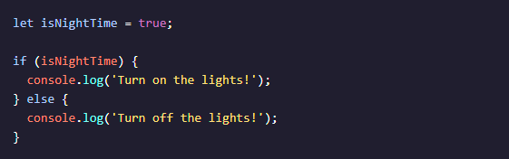

We can use a *ternary operator* to perform the same functionality:

;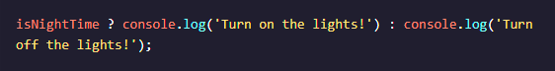

In the example above:

* The condition, isNightTime, is provided before the ?.
* Two expressions follow the ? and are separated by a colon :.
* If the condition evaluates to true, the first expression executes.
* If the condition evaluates to false, the second expression executes.

Like if...else statements, ternary operators can be used for conditions which evaluate to true or false.